

**SCHOOL OF COMPUTER SCIENCE ENGINEERING**

**AND INFORMATION SYSTEMS**

**WINTER SEMESTER 2024-2025**

**PMCA601P – FULL STACK WEB DEVELOPMENT LAB**

**CYCLESHEET PAT – 1**

**SUBMITTED ON: 06 – JAN - 2025**

**SUBMITTED BY-**

**AKASH KUMAR BANIK**

**PROGRAM: MCA**

**REGISTER No.: 24MCA0242**

**HTML EXERCISES**

**1. HTML Text formatting**

**a. Print the squares of the numbers 1 - 20. Each number should be on a separate line, next to it the number 2 superscripted, an equal sign and the result.**

**CODE:**

<!DOCTYPE html>

<html lang="en">

<head>

    <meta charset="UTF-8">

    <meta name="viewport" content="width=device-width, initial-scale=1.0">

    <title>Document</title>

</head>

<body>

    <h2>Squares of 1 - 20</h2>

    <p>1 <sup>2</sup>=1</p>

    <p>2 <sup>2</sup>=4</p>

    <p>3 <sup>2</sup>=9</p>

    <p>4 <sup>2</sup>=16</p>

    <p>5 <sup>2</sup>=25</p>

    <p>6 <sup>2</sup>=36</p>

    <p>7 <sup>2</sup>=49</p>

    <p>8 <sup>2</sup>=64</p>

    <p>9 <sup>2</sup>=81</p>

    <p>10 <sup>2</sup>=100</p>

    <p>11 <sup>2</sup>=121</p>

    <p>12 <sup>2</sup>=144</p>

    <p>13 <sup>2</sup>=169</p>

    <p>14 <sup>2</sup>=196</p>

    <p>15 <sup>2</sup>=225</p>

    <p>16 <sup>2</sup>=256</p>

    <p>17 <sup>2</sup>=289</p>

    <p>18 <sup>2</sup>=324</p>

    <p>19 <sup>2</sup>=361</p>

    <p>20 <sup>2</sup>=400</p>

</body>

</html>

**OUTPUT:**

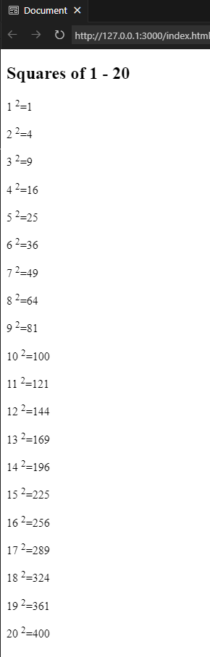

**b. Print two lists with any information you want. One list should be an ordered list, the other list should be an unordered list.**

**CODE:**

<!DOCTYPE html>

<html lang="en">

<head>

<meta charset="UTF-8">

<meta name="viewport" content="width=device-width, initial-scale=1.0">

<title>Document</title>

</head>

<body>

<h2>Operators in C</h2>

<ol>

<li>Arithmetic Operators</li>

<li>Relational Operators</li>

<li>Logical Operators</li>

<li>Assignment Operators</li>

<li>Ternary Operator</li>

<li>Bitwise Operator</li>

</ol>

<h2>Computer Brands</h2>

<ul>

<li>DELL</li>

<li>HP</li>

<li>Alienware</li>

<li>Asus</li>

<li>msi</li>

<li>Acer</li>

<li>Lenovo</li>

</ul>

</body>

</html>

**OUTPUT:**

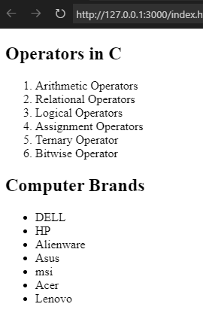

**c. Print a list which starts with 7 with the type i.**

**CODE:**

<!DOCTYPE html>

<html lang="en">

<head>

    <meta charset="UTF-8">

    <meta name="viewport" content="width=device-width, initial-scale=1.0">

    <title>Document</title>

</head>

<body>

    <h2>Computer Brands</h2>

    <ol type="i" start="7">

        <li>DELL</li>

        <li>HP</li>

        <li>Alienware</li>

        <li>Asus</li>

        <li>msi</li>

        <li>Acer</li>

        <li>Lenovo</li>

    </ol>

</body>

</html>

**OUTPUT:**

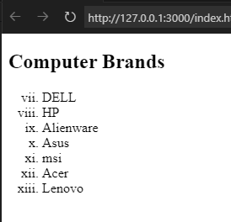

**d. Prints an h1 level heading followed by a horizontal line whose width is 100%. Below the horizontal line print a paragraph relating to the text in the heading.**

**CODE:**

<!DOCTYPE html>

<html lang="en">

<head>

<meta charset="UTF-8">

<meta name="viewport" content="width=device-width, initial-scale=1.0">

<title>Document</title>

<style>

h1{

text-align: center;

}

p{

text-align: justify;

padding: 0 20px 0 20px;

font-size: larger;

}

</style>

</head>

<body>

<h1>Full Stack Web Development</h1>

<hr>

<p>This is Full Stack Web Development Lab class. We are assigned with the task of brushing up our HTML and CSS concepts and creating some basic static web pages.</p>

<p>Lorem ipsum dolor sit amet consectetur adipisicing elit. Dignissimos voluptates commodi distinctio impedit unde omnis! Ut quam vel culpa rem laborum quo. Veritatis possimus officia cupiditate voluptatum corporis minus, velit ut animi sint, numquam aut. Nesciunt rerum quaerat ad quam quidem minus reprehenderit, distinctio dolor adipisci doloremque, ab quos, nobis accusantium quibusdam sunt delectus ratione ullam dicta veritatis. Cumque, quia obcaecati voluptates voluptatem iste rem quidem eius quasi fugit architecto, ad nam maiores laboriosam ullam aperiam culpa, repellat id. Beatae accusamus quasi explicabo, consectetur necessitatibus ex harum doloremque eveniet doloribus, eos inventore! Repellendus praesentium officia quos excepturi voluptatum reprehenderit, nisi vero recusandae aut obcaecati doloribus voluptate, dolorum similique, architecto inventore sapiente. Nam possimus praesentium quidem iste ab obcaecati, porro delectus facere, doloribus itaque modi necessitatibus velit maxime cumque tenetur deserunt earum unde officiis cupiditate molestiae aperiam laborum excepturi, similique incidunt! Beatae laudantium esse cupiditate aliquid iste illum rem repudiandae porro libero minus, dolore modi odit aut doloremque corporis vero magni vitae voluptate, aliquam tempore magnam dignissimos ullam exercitationem. A et nihil officiis voluptatibus ad amet ratione obcaecati facilis earum similique quasi fugit ipsum odio, accusamus quos dolorum laboriosam praesentium neque, maxime repudiandae ab. Libero soluta nam error molestiae quisquam facilis!</p>

</body>

</html>

**OUTPUT:**

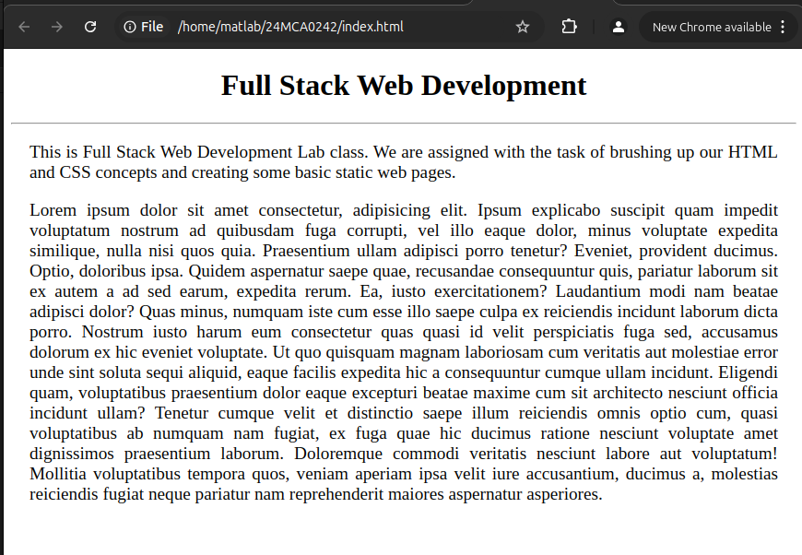

**e. Print a definition list with 5 items.**

**CODE:**

<!DOCTYPE html>

<html lang="en">

<head>

<meta charset="UTF-8">

<meta name="viewport" content="width=device-width, initial-scale=1.0">

<title>Document</title>

</head>

<body>

<h2>Full Stack Web Development</h2>

<dl>

<dt>Front-end</dt>

<dd>This deals with creating the user interface of the website. Technologies used here include: HTML, CSS, JavaScript, ReactJS, AngularJS.</dd>

<br>

<dt>Back-end</dt>

<dd>This deals with creating the database and related operations of the website. Technologies used here include: SQL, NoSQL, MongoDB, NodeJS, PostgreSQL.</dd>

<br>

<dt>List Heading 3</dt>

<dd>Lorem ipsum dolor sit amet consectetur adipisicing elit. Quasi, quo pariatur ea incidunt, iustoperspiciatis distinctio nulla dolorum at suscipit asperiores qui voluptates officiis tenetur rerum. Debitis quibusdam rerum libero, molestias magnam ipsam architecto voluptate dignissimos nisi dolorum qui earum. Fugiat error est atque explicabo, autem cupiditate iusto repellendus velit.</dd>

<br>

<dt>List Heading 4</dt>

<dd>Lorem ipsum dolor sit amet consectetur adipisicing elit. Ad sunt saepe tempora ullam totam architecto odit eum quae veniam aperiam necessitatibus quia tempore, cupiditate culpa magni, esse magnam et sequi.</dd>

<br>

<dt>List Heading 4</dt>

<dd>Lorem ipsum dolor sit amet, consectetur adipisicing elit. Porro dicta quia veniam alias ab illo maxime iusto recusandae modi voluptates?</dd>

</dl>

</body>

</html>

**OUTPUT:**

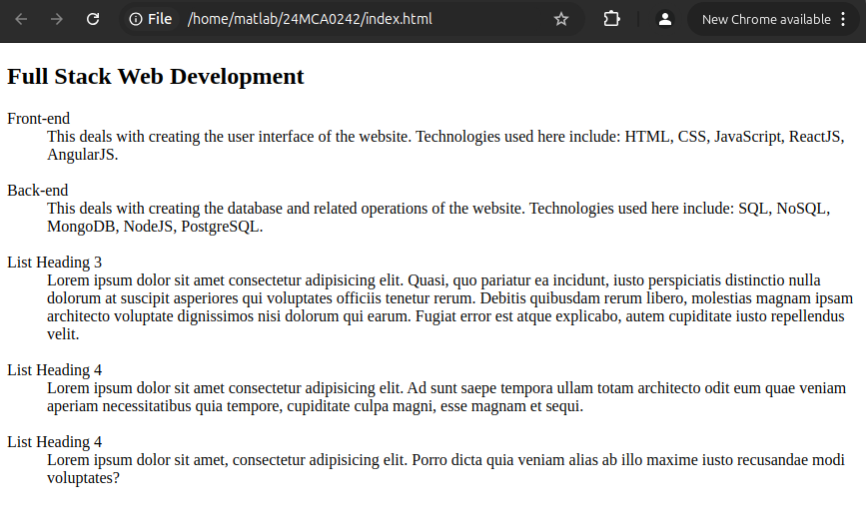

**f. Print two addresses in the same format used on the front of envelopes (senders address in top left corner, receivers address in the center).**

**CODE:**

<!DOCTYPE html>

<html lang="en">

<head>

<meta charset="UTF-8">

<meta name="viewport" content="width=device-width, initial-scale=1.0">

<title>Document</title>

<style>

body{

border: 2px solid black;

padding: 20px;

}

.add2{

justify-items: center;

}

</style>

</head>

<body>

<div class="add1">

<h3>From</h3>

<p>Mr. Akash Kr. Banik</p>

<p>MG Road, New Delhi,</p>

<p>Pincode: 698536</p>

</div>

<div class="add2">

<h3>To</h3>

<p>Mr. Karan Maurya</p>

<p>MK Road, New Mumbai,</p>

<p>Pincode: 690036</p>

</div>

</body>

</html>

**OUTPUT:**

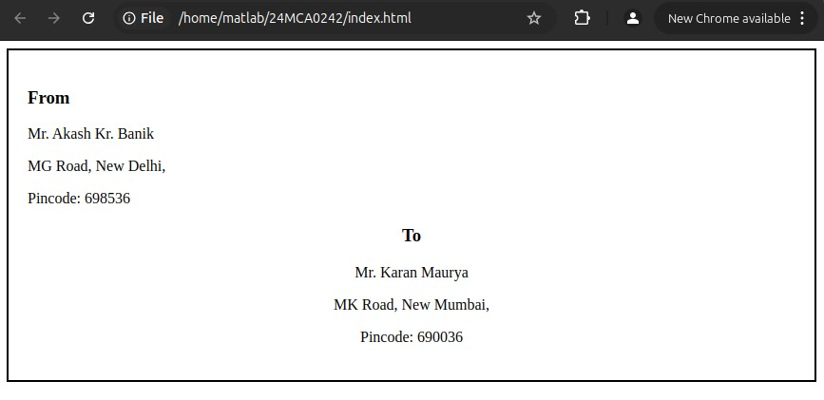

**g. Print ten acronyms and abbreviations of your choice, each separated by two lines. Specify the data that the abbreviations and acronyms represent.**

**CODE:**

<!DOCTYPE html>

<html lang="en">

<head>

<meta charset="UTF-8">

<meta name="viewport" content="width=device-width, initial-scale=1.0">

<title>Document</title>

<style>

body{

border: 2px solid black;

padding: 20px;

}

</style>

</head>

<body>

<acronym title="World Wide Web">WWW</acronym><br><br>

<acronym title="Hyper Text Markup Language">HTML</acronym><br><br>

<acronym title="Cascading Style Sheet">css</acronym><br><br>

<acronym title="World Wide Web Consortium">W3C</acronym><br><br>

<acronym title="Transaction Control Protocol">TCP</acronym><br><br>

<acronym title="Internet Protocol">IP</acronym><br><br>

<acronym title="Dynamic Host Configuration Protocol">DHCP</acronym><br><br>

<acronym title="Internet Control Message Protocol">ICMP</acronym><br><br>

<acronym title="User Datagram Protocol">UDP</acronym><br><br>

<acronym title="Simple Mail Transfer Protocol">SMTP</acronym><br><br>

</body>

</html>

**OUTPUT:**

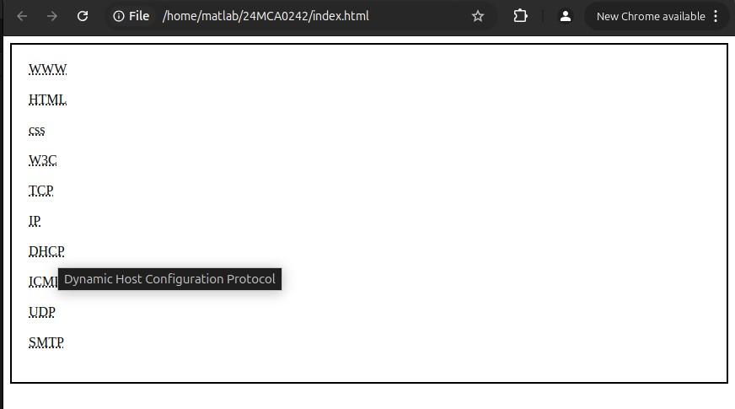

**2. HTML IMAGE EXERCISES**

**a. Display five different images. Skip two lines between each image. Each image should have a title.**

**CODE:**

<!DOCTYPE html>

<html lang="en">

<head>

<meta charset="UTF-8">

<meta name="viewport" content="width=device-width, initial-scale=1.0">

<title>Document</title>

</head>

<body>

<img src="images/img1.jpg" alt="Imgae1" title="This is flower image" height="350em"><br>

<label for="img">This is flower image</label>

<br><br><br>

<img src="images/img1.jpg" alt="Imgae1" title="This is flower image" height="350em"><br>

<label for="img">This is flower image</label>

<br><br><br>

<img src="images/img1.jpg" alt="Imgae1" title="This is flower image" height="350em"><br>

<label for="img">This is flower image</label>

<br><br><br>

<img src="images/img1.jpg" alt="Imgae1" title="This is flower image" height="350em"><br>

<label for="img">This is flower image</label>

<br><br><br>

<img src="images/img1.jpg" alt="Imgae1" title="This is flower image" height="350em"><br>

<label for="img">This is flower image</label>

<br><br><br>

</body>

</html>

**OUTPUT:**

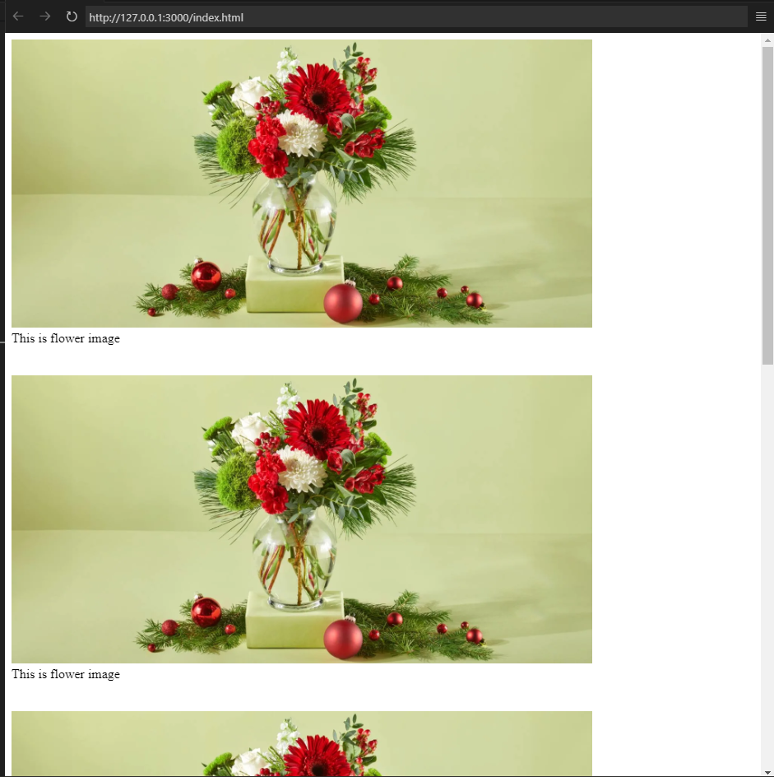

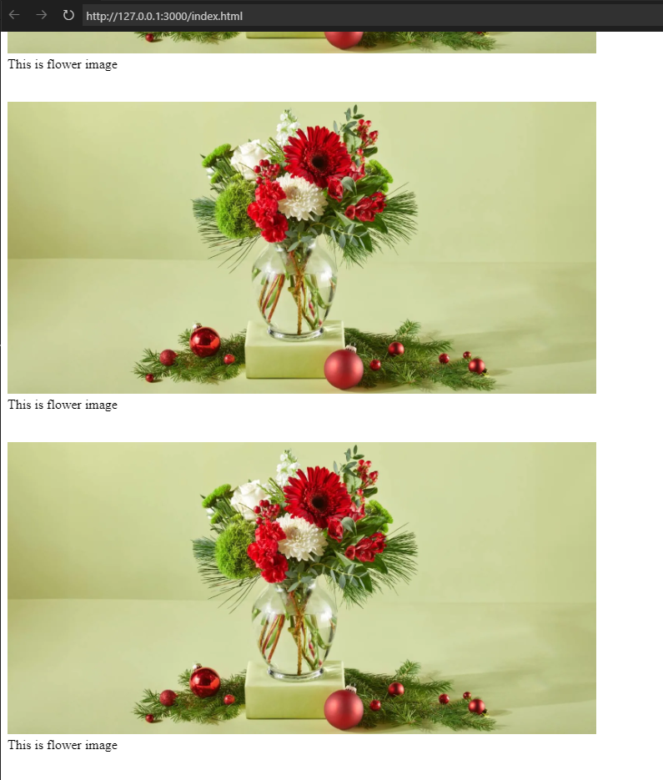

**b. Display an image that has a border of size 2, a width of 200, and a height of 200.**

**CODE:**

<!DOCTYPE html>

<html lang="en">

<head>

<meta charset="UTF-8">

<meta name="viewport" content="width=device-width, initial-scale=1.0">

<title>Document</title>

</head>

<body>

<img src="images/img1.jpg" alt="Imgae1" width="200" height="200" style="border: 2px blue solid;"><br>

<label for="img">This is flower image</label>

<br><br><br>

</body>

</html>

**OUTPUT:**

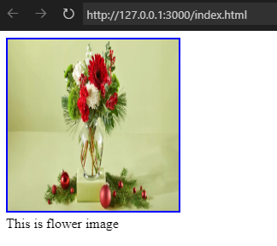

**c. Display the image towards the right corner of the webpage.**

**CODE:**

<!DOCTYPE html>

<html lang="en">

<head>

<meta charset="UTF-8">

<meta name="viewport" content="width=device-width, initial-scale=1.0">

<title>Document</title>

<style>

img{

border: 5px blue solid;

float: right;

}

</style>

</head>

<body>

<img src="images/img1.jpg" alt="Imgae1" width="200" height="200"><br>

</body>

</html>

**OUTPUT:**

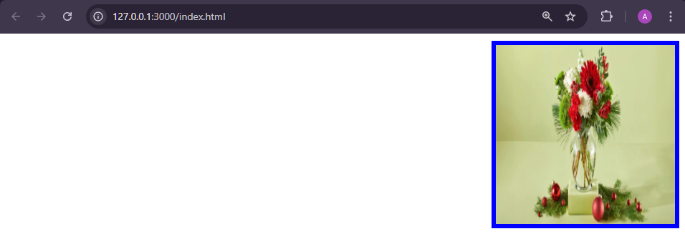

**3. HTML LIST EXERCISES**

**I. Program to illustrate Nested ordered list and Definition lists**

**a. Solid gray banner along the top of the browser window**

**i. company logo**

**ii. product image**

**b. A text-based navigation menu**

**i. Links to each of the site’s web documents**

**c. A content area**

**i. A heading that identifies page content**

**ii. A paragraph for displaying content**

**iii. A copyright notice**

**CODE:**

<!DOCTYPE html>

<html lang="en">

<head>

<meta charset="UTF-8">

<meta name="viewport" content="width=device-width, initial-scale=1.0">

<title>Nested Lists and Definition Lists</title>

<style>

body {

font-family: Arial, sans-serif;

margin: 0;

padding: 0;

}

header {

background-color: gray;

color: white;

padding: 10px 0;

text-align: center;

}

nav {

background-color: #333;

overflow: hidden;

}

nav a {

color: white;

padding: 14px 20px;

display: inline-block;

text-decoration: none;

}

nav a:hover {

background-color: #ddd;

color: black;

}

.container {

padding: 20px;

}

.content {

margin-top: 20px;

}

footer {

text-align: center;

margin-top: 40px;

font-size: 12px;

color: #777;

}

</style>

</head>

<body>

<!-- Solid gray banner along the top -->

<header>

<h1>Company Website</h1>

<ul>

<li><img src="images/img1.jpg" alt="Company Logo" width="350"></li>

<li><img src="images/img2.jpg" alt="Product Image" width="200"></li>

</ul>

</header>

<!-- Text-based navigation menu -->

<nav>

<a href="#home">Home</a>

<a href="#about">About</a>

<a href="#services">Services</a>

<a href="#contact">Contact</a>

</nav>

<!-- Content area -->

<div class="container">

<div class="content">

<h2>Page Content</h2>

<p>This is a sample page demonstrating nested ordered lists and definition lists in HTML.</p>

<ol>

<li>Solid gray banner along the top of the browser window

<ol>

<li>Company logo</li>

<li>Product image</li>

</ol>

</li>

<li>A text-based navigation menu

<ol>

<li>Links to each of the site’s web documents</li>

</ol>

</li>

<li>A content area

<ol>

<li>A heading that identifies page content</li>

<li>A paragraph for displaying content</li>

<li>A copyright notice</li>

</ol>

</li>

</ol>

</div>

</div>

<!-- Footer with copyright notice -->

<footer>

<p>&copy; 2024 Company Name. All rights reserved.</p>

</footer>

</body>

</html>

**OUTPUT:**

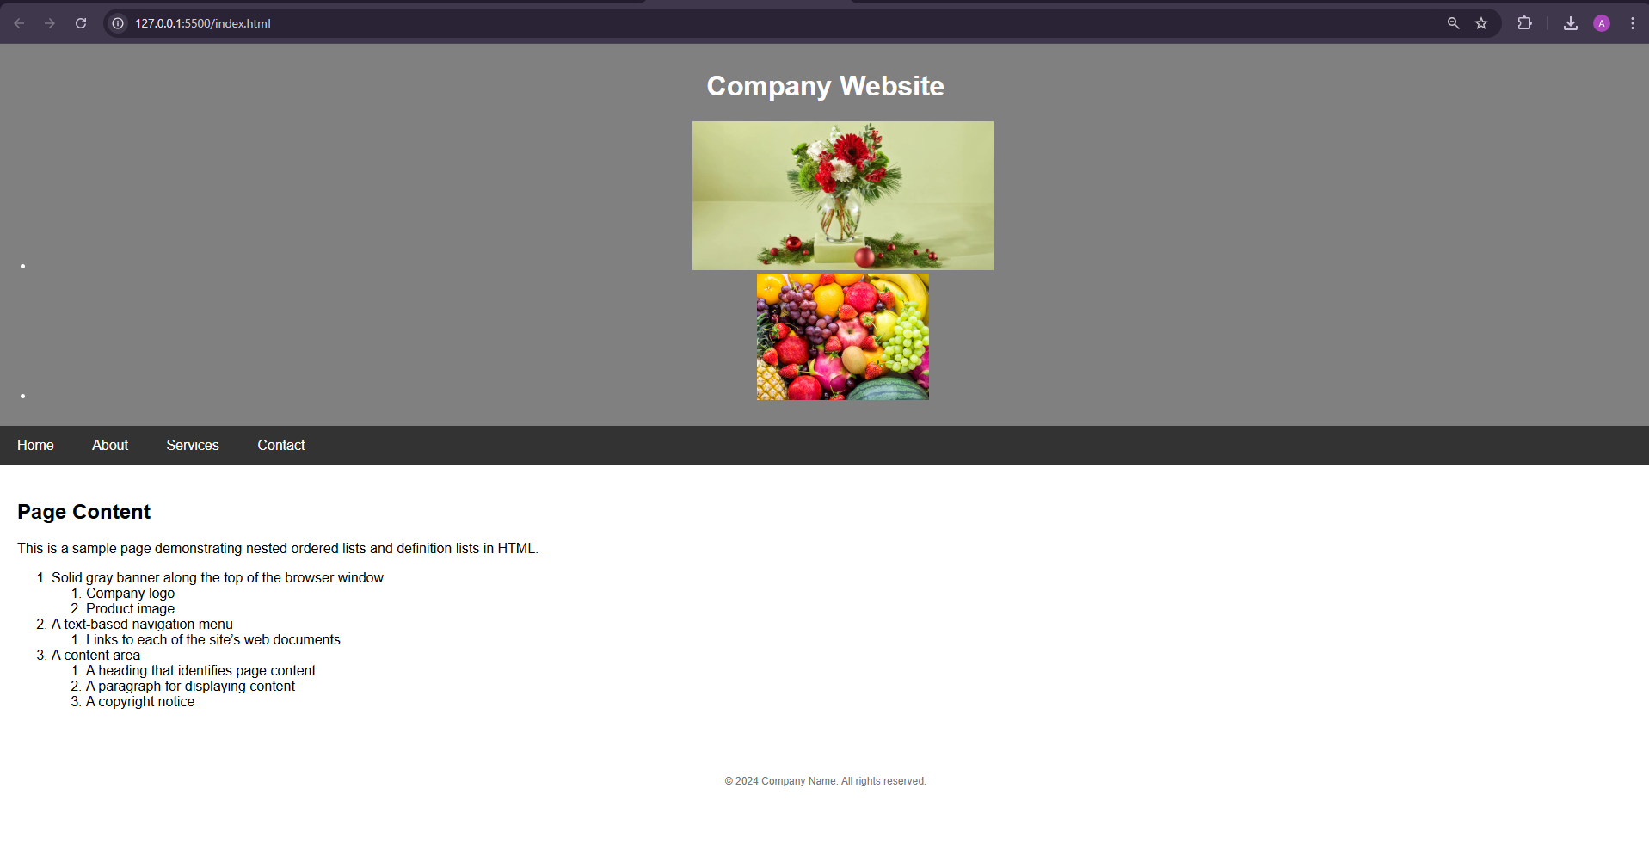

**II. Create the following list using HTML.**

**CODE:**

<!DOCTYPE html>

<html lang="en">

<head>

<meta charset="UTF-8" />

<meta name="viewport" content="width=device-width, initial-scale=1.0" />

<title>Document</title>

<style>

h1 {

text-align: center;

}

</style>

</head>

<body>

<h1>To illustrate Nested and Definition List Tags</h1>

<hr size="5px" color="darkgrey" />

<h2>An Ordered List</h2>

<ol type="1">

<li>Cofee</li>

<li>

Tea

<ol type="a">

<li>Black Tea</li>

<li>

Green Tea

<ol type="i">

<li>China</li>

<li>Africa</li>

</ol>

</li>

</ol>

</li>

<li>Milk</li>

</ol>

<h2>A Definition List</h2>

<dl>

<dt>Bangalore</dt>

<dd>-Capital City of Karnataka</dd>

<dt>Mumbai</dt>

<dd>-Capital City of Maharashtra</dd>

</dl>

</body>

</html>

**OUTPUT:**

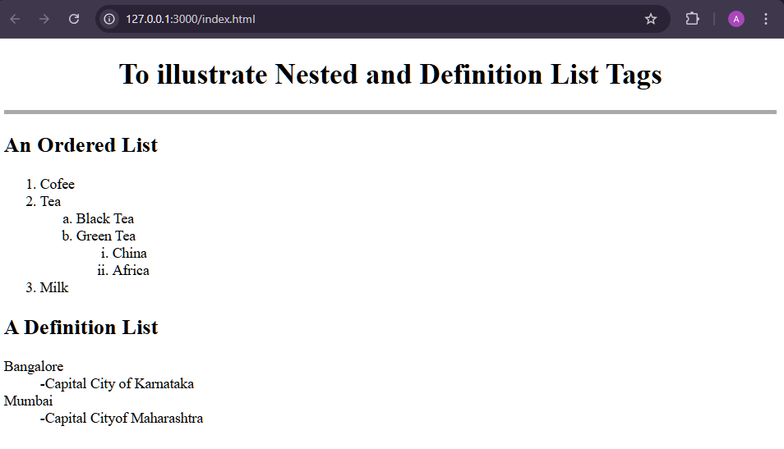

**III. Create the following list using HTML tags**

**CODE:**

<!DOCTYPE html>

<html lang="en">

<head>

<meta charset="UTF-8">

<meta name="viewport" content="width=device-width, initial-scale=1.0">

<title>Document</title>

</head>

<body>

<h2>List Examples</h2>

<hr size="5px" color="darkgrey">

<p>This is an unordered list</p>

<ul>

<li>List Item 1</li>

<li>List Item 2</li>

<li>List Item 3</li>

</ul>

<p>This is an ordered list</p>

<ol>

<li>List Item 1</li>

<li>List Item 2</li>

<li>List Item 3</li>

</ol>

<p>This is an ordered list starting at 10 and in upper-case roman numerals</p>

<ol type="I" start="10">

<li>List Item 1</li>

<li>List Item 2</li>

<li>List Item 3</li>

</ol>

<p>This is an unordered list nestewd within an ordered list</p>

<ol>

<li>Walk the dog</li>

<li>Wash the car</li>

<li>Get groceries

<ul>

<li>Gound beef</li>

<li>Mozzarella</li>

<li>Lasagna Noodles</li>

<li>Pasta Sauce</li>

<li>Ricotta Cheese</li>

</ul>

</li>

<li>Clean the house</li>

<li>Take out garbage</li>

</ol>

</body>

</html>

**OUTPUT:**

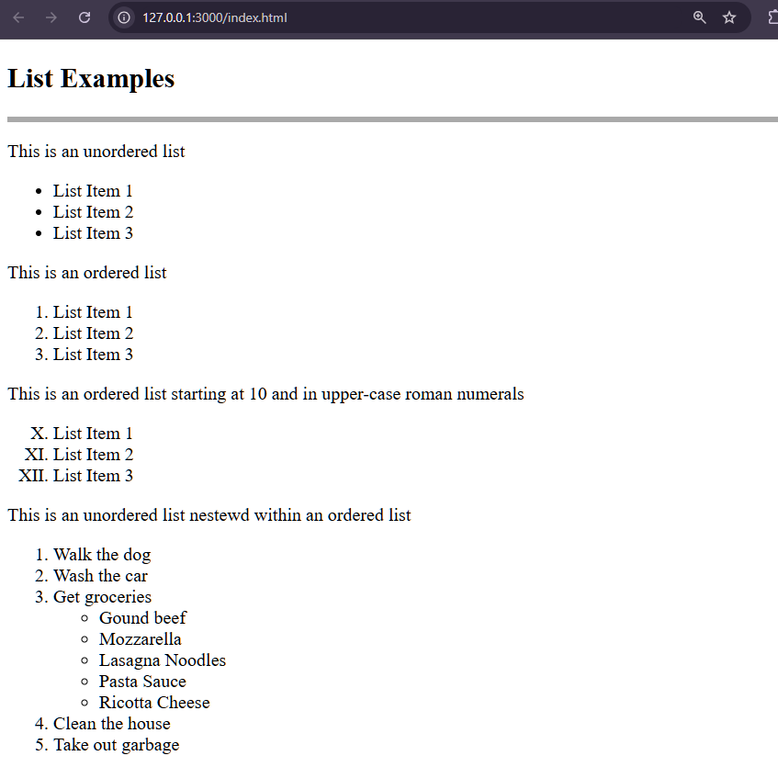

**4. HTML TABLE EXERCISES**

**Create the following tables using HTML code.**

**A. Pick 5 company stocks and hunt down their current stock prices.**

**i) Place them in a neatly arranged table with their name, symbol, last price, 52wk high, 52wk low and PE ratio.**

**ii) The end result should look like the following. Notice that the first column is aligned left and the rest are centered.**

**CODE:**

<!DOCTYPE html>

<html lang="en">

<head>

<meta charset="UTF-8">

<meta name="viewport" content="width=device-width, initial-scale=1.0">

<title>Document</title>

<style>

table, tr, td, th {

border: 5px salmon solid;

border-collapse: collapse;

padding: 10px;

}

.left {

text-align: left;

}

</style>

</head>

<body>

<h2>TABLE Examples</h2>

<hr size="5px" color="darkgrey">

<table>

<tr>

<th colspan="6"><i>My tech stock picks</i></th>

</tr>

<tr>

<th class="left">NAME</th>

<th>SYMBOL</th>

<th>CURRENT</th>

<th>52WK HIGH</th>

<th>52WK LOW</th>

<th>P/E RATIO</th>

</tr

<tr>

<td>Microsoft</td>

<td>MSFT</td>

<td>86-3/8</td>

<td>119-15/16</td>

<td>75-1/2</td>

<td>56.09</td>

</tr>

<tr>

<td>Cisco Systems</td>

<td>CSCO</td>

<td>72-1/8</td>

<td>82</td>

<td>24-13/16</td>

<td>400.69</td>

</tr>

<tr>

<td>America Online</td>

<td>AOL</td>

<td>63</td>

<td>95-13/16</td>

<td>38-15/32</td>

<td>350.00</td>

</tr>

<tr>

<td>Qwest Communications</td>

<td>Q</td>

<td>44-7/16</td>

<td>66</td>

<td>25-3/4</td>

<td>74.06</td>

</tr>

<tr>

<td>Dell Computers</td>

<td>DELL</td>

<td>53-59/64</td>

<td>59-11/16</td>

<td>31-3/8</td>

<td>86.97</td>

</tr>

</table>

</body>

</html>

**OUTPUT:**

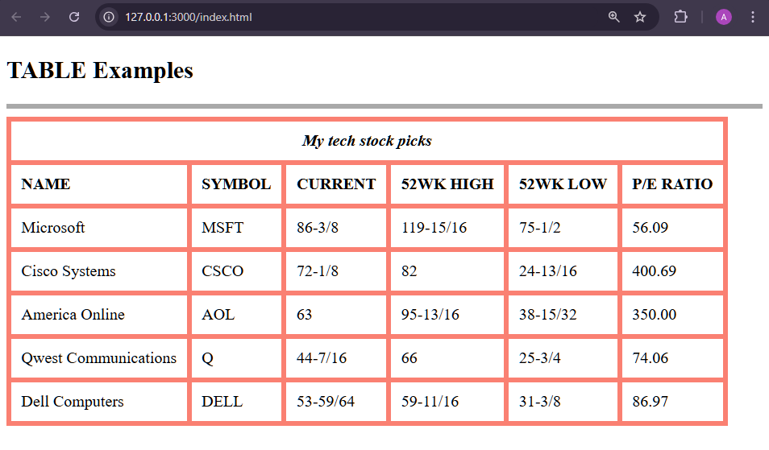

**iii) Now alter the last table with dashed line with red color.**

**CODE:**

<!DOCTYPE html>

<html lang="en">

<head>

<meta charset="UTF-8">

<meta name="viewport" content="width=device-width, initial-scale=1.0">

<title>Document</title>

<style>

table,

tr,

td,

th {

border: 5px salmon solid;

border-collapse: collapse;

padding: 10px;

text-align: center;

}

.left {

text-align: left;

}

</style>

</head>

<body>

<h2>TABLE Examples</h2>

<hr size="5px" color="darkgrey">

<table>

<tr>

<th colspan="6"><i>My tech stock picks</i></th>

</tr>

<tr>

<th class="left">NAME</th>

<th>SYMBOL</th>

<th>CURRENT</th>

<th>52WK HIGH</th>

<th>52WK LOW</th>

<th>P/E RATIO</th>

</tr>

<tr>

<td class="left">Microsoft</td>

<td>MSFT</td>

<td>86-3/8</td>

<td>119-15/16</td>

<td>75-1/2</td>

<td>56.09</td>

</tr>

<tr>

<td class="left">Cisco Systems</td>

<td>CSCO</td>

<td>72-1/8</td>

<td>82</td>

<td>24-13/16</td>

<td>400.69</td>

</tr>

<tr>

<td class="left">America Online</td>

<td>AOL</td>

<td>63</td>

<td>95-13/16</td>

<td>38-15/32</td>

<td>350.00</td>

</tr>

<tr>

<td class="left">Qwest Communications</td>

<td>Q</td>

<td>44-7/16</td>

<td>66</td>

<td>25-3/4</td>

<td>74.06</td>

</tr>

<tr style="border: 5px blue dotted;">

<td class="left" style="border: 5px blue dotted;">Dell Computers</td>

<td style="border: 5px blue dotted;">DELL</td>

<td style="border: 5px blue dotted;">53-59/64</td>

<td style="border: 5px blue dotted;">59-11/16</td>

<td style="border: 5px blue dotted;">31-3/8</td>

<td style="border: 5px blue dotted;">86.97</td>

</tr>

</table>

</body>

</html>

**OUTPUT:**

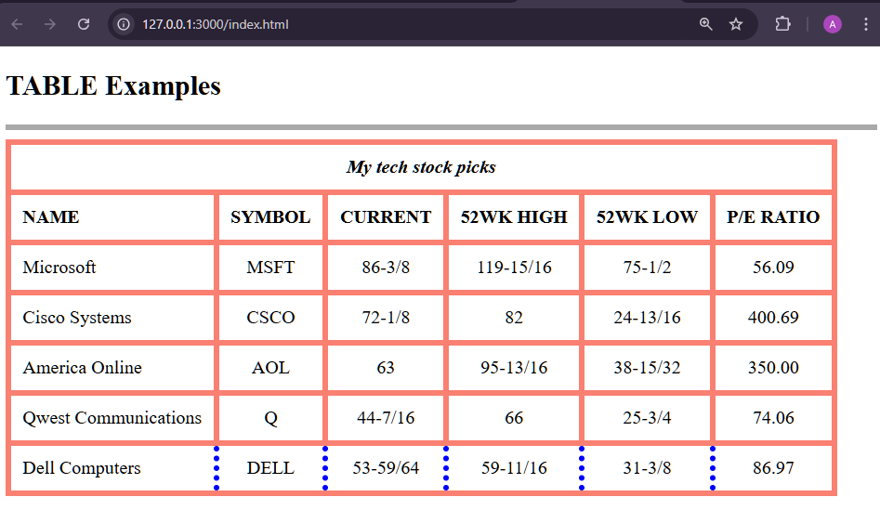

**B. List of Fruits**

**CODE:**

<!DOCTYPE html>

<html lang="en">

<head>

<meta charset="UTF-8">

<meta name="viewport" content="width=device-width, initial-scale=1.0">

<title>Document</title>

<style>

table,tr,td,th{

border: 5px black solid;

border-collapse: collapse;

padding: 10px;

text-align: center;

width: 80%;

}

</style>

</head>

<body>

<h2>TABLE Examples</h2>

<hr size="5px" color="darkgrey">

<table>

<tr>

<th colspan="2"><i>Fresh Fruits</i></th>

</tr>

<tr>

<td>It has long been known that a diet that includes at least a few servings of fresh fruit every day will help keep you healthy, fit and trim</td>

<td><img src="images/img2.jpg" alt="ubuntu logo" height="100px"></td>

</tr>

</table>

</body>

</html>

**OUTPUT:**

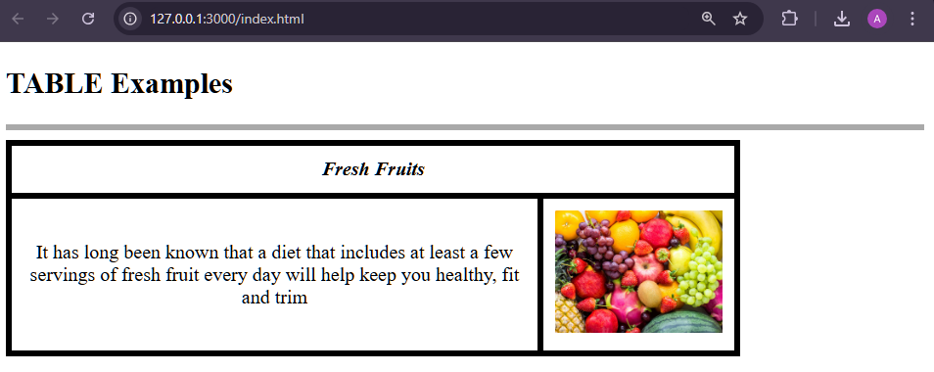

**C. Time Table**

**CODE:**

<!DOCTYPE html>

<html lang="en">

<head>

<meta charset="UTF-8">

<meta name="viewport" content="width=device-width, initial-scale=1.0">

<title>Document</title>

<style>

* {

text-align: center;

align-items: center;

font-weight: bolder;

justify-items: center;

}

table,tr,td,th {

border: 2px black solid;

border-collapse: separate;

padding: 10px;

text-align: center;

}

h2{

color: brown;

}

body{

background-color: aqua;

}

.purple{

color: purple;

}

.red{

color: red;

}

.green{

color: green;

}

.darkgreen{

color: darkgreen;

}

</style>

</head>

<body>

<h2>COLLEGE TABLE TABLE</h2>

<table>

<tr>

<th></th>

<th>8:30-9:30</th>

<th>9:30-10:30</th>

<th>10:30-11:30</th>

<th>11:30-12:30</th>

<th>12:30-2:00</th>

<th>2:00-3:00</th>

<th>3:00-4:00</th>

<th>4:00-5:00</th>

</tr>

<tr>

<td><b>MONDAY</b></td>

<td>---</td>

<td class="purple">SUB1</td>

<td>SUB2</td>

<td class="red">SUB3</td>

<td rowspan="6">LUNCH</td>

<td>SUB4</td>

<td class="red">SUB5</td>

<td>counselling class</td>

</tr>

<tr>

<td><b>TUESDAY</b></td>

<td class="purple">SUB1</td>

<td class="red">SUB2</td>

<td>SUB3</td>

<td>---</td>

<td class="green">SUB4</td>

<td>SUB5</td>

<td>library</td>

</tr>

<tr>

<td><b>WEDNESDAY</b></td>

<td>SUB1</td>

<td class="green">SUB2</td>

<td class="red">SWA</td>

<td>---</td>

<td colspan="3" class="darkgreen">lab</td>

</tr>

<tr>

<td><b>THURSDAY</b></td>

<td>SUB1</td>

<td class="red">SUB2</td>

<td class="green">SUB3</td>

<td>---</td>

<td class="purple">SUB4</td>

<td class="red">SUB5</td>

<td>library</td>

</tr>

<tr>

<td><b>FRIDAY</b></td>

<td class="green">SUB1</td>

<td>SUB2</td>

<td class="purple">SUB3</td>

<td>---</td>

<td>SUB4</td>

<td class="red">SUB5</td>

<td>library</td>

</tr>

<tr>

<td><b>SATURDAY</b></td>

<td class="red">SUB1</td>

<td colspan="3">seminar</td>

<td>SUB4</td>

<td class="red">SUB5</td>

<td>library</td>

</tr>

</table>

</body>

</html>

**OUTPUT:**

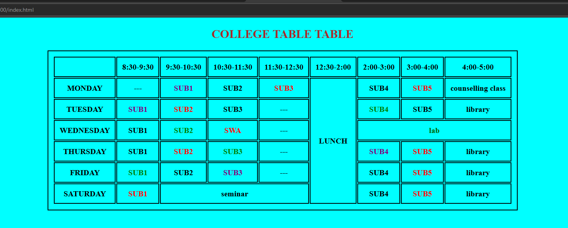

**5. HTML LINK EXERCISES**

**A. Create links to five different already created pages.**

**CODE:**

<!DOCTYPE html>

<html lang="en">

<head>

<meta charset="UTF-8">

<meta name="viewport" content="width=device-width, initial-scale=1.0">

<title>Document</title>

<style>

* {

text-align: center;

font-weight: bolder;

justify-items: center;

font-size: larger;

}

</style>

</head>

<body>

<a href="https://www.google.com/" target="_blank">Google</a> <br><br>

<a href="http://yahoo.com" target="_blank"">yahoo</a> <br><br>

<a href="http://brave.com" target="_blank">Brave</a> <br><br>

<a href="http://www.youtube.com" target="_blank">YouTube</a> <br><br>

<a href="https://www.apple.com/in/safari/" target="_blank">Safari</a>

</body>

</html>

**OUTPUT:**

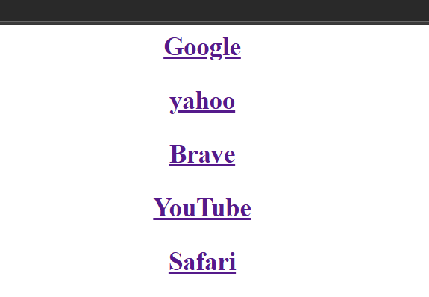

**B. Create a page with a link at the top of it that when clicked will jump all the way to the bottom of the page. At the bottom of the page there should be a link to jump back to the top of the page.**

**CODE:**

<!DOCTYPE html>

<html lang="en">

<head>

<meta charset="UTF-8">

<meta name="viewport" content="width=device-width, initial-scale=1.0">

<title>Jump Links</title>

</head>

<body>

<h1><a href="#bottom">Jump to Bottom</a></h1>

<div>

<p style="padding: 20px; text-align: justify;">Lorem1500</p>

</div>

<h1><a id="bottom" href="#top">Jump to Top</a></h1>

</body>

</html>

**OUTPUT:**

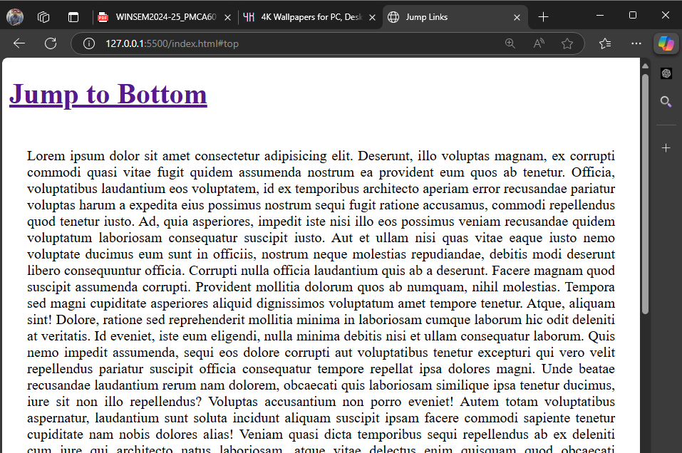

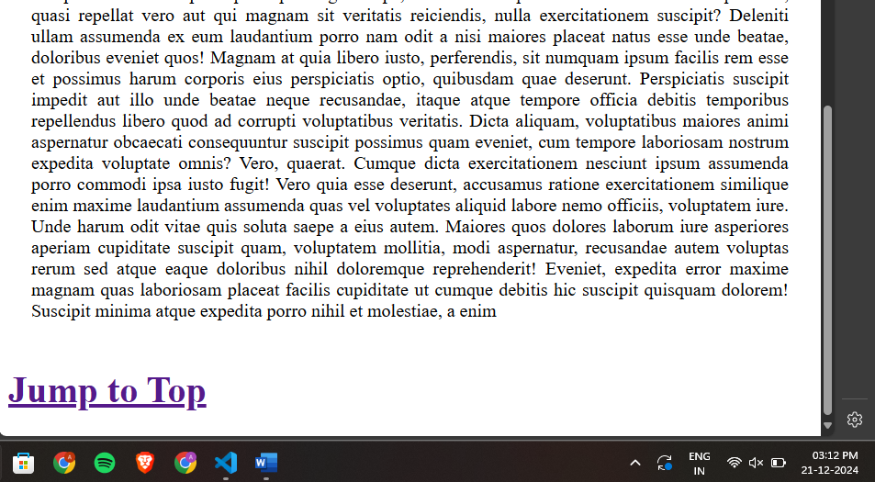

**C. Write an HTML code to create a Home page having three links: About Us, Our Services and Contact Us. Create separate web pages for the three links.**

**CODE:**

<!DOCTYPE html>

<html lang="en">

<head>

<meta charset="UTF-8">

<meta name="viewport" content="width=device-width, initial-scale=1.0">

<title>Document</title>

<style>

* {

text-align: center;

align-items: center;

font-weight: bolder;

justify-items: center;

font-size: larger;

}

</style>

</head>

<body>

<nav>

<ul style="list-style-type: none;">

<li><a href="pg1.html" target="_blank">Home</a></li>

<li><a href="pg2.html" target="_blank"">About Us</a></li>

<li><a href="pg3.html" target="_blank">Our Services</a></li>

</ul>

</nav>

</body>

</html>

**OUTPUT:**

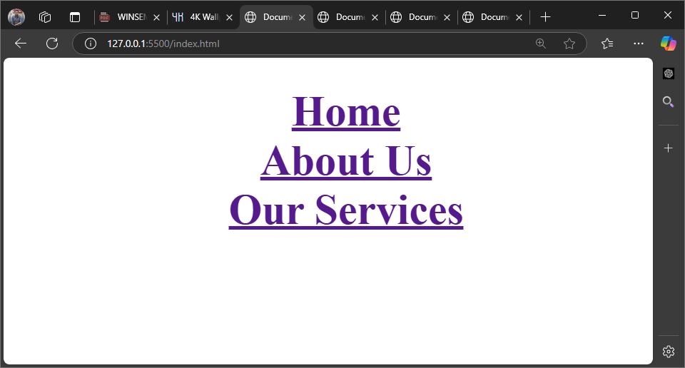

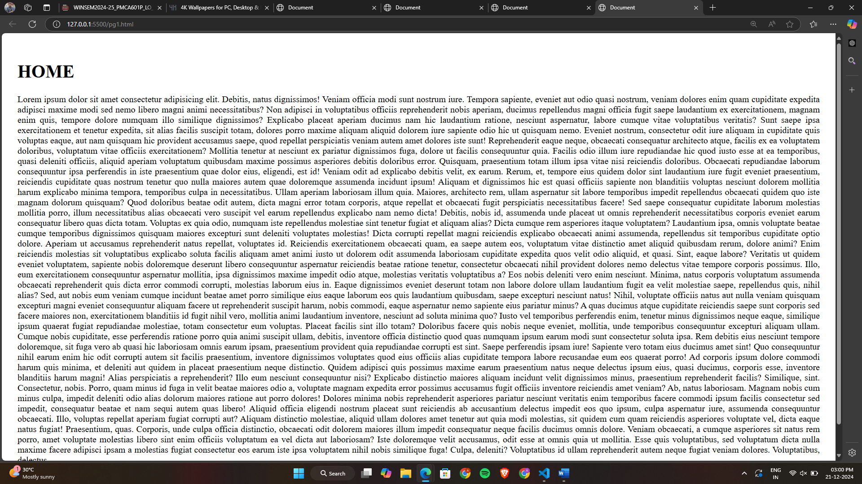

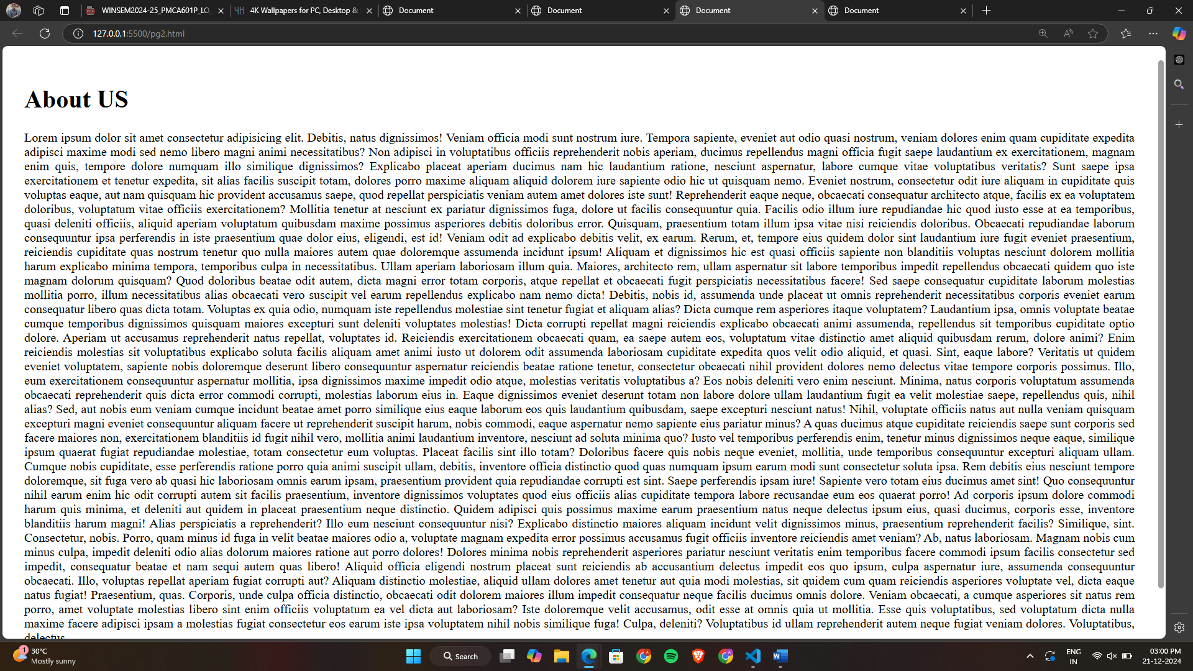

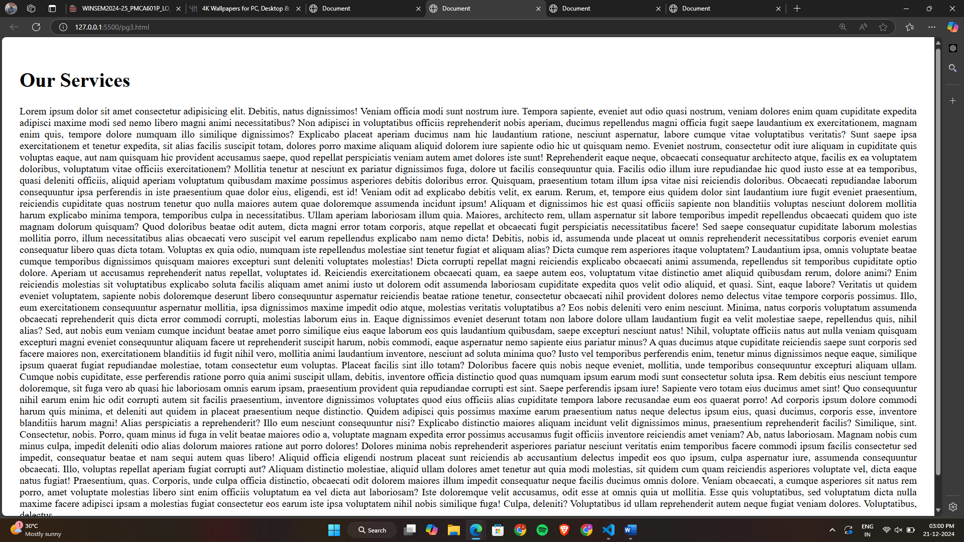

**6. HTML FORM EXERCISES**

**A. Design the following form using HTML**

**CODE:**

<!DOCTYPE html>

<html lang="en">

<head>

<meta charset="UTF-8">

<meta name="viewport" content="width=device-width, initial-scale=1.0">

<title>Jump Links</title>

<style>

table,tr,td,th{

border: 1px black solid;

}

</style>

</head>

<body>

<table>

<tr>

<th colspan="2">Pizza Shop 2.0</th>

</tr>

<tr>

<td>Name</td>

<td>

<input type="text" name="name" id="name">

</td>

</tr>

<tr>

<td>Pizza Topping</td>

<td>

<input type="radio" name="ptop" id=""> Supreme <br>

<input type="radio" name="ptop" id=""> Vegetarian <br>

<input type="radio" name="ptop" id=""> Hawaiian

</td>

</tr>

<tr>

<td>Pizza Sauce</td>

<td>

<select name="psauce" id="">

<option value="Tomato">Tomato</option>

<option value="Chicken">Chicken</option>

<option value="Dcheese">Double Cheese</option>

</select>

</td>

</tr>

<tr>

<td>Optional Extras</td>

<td>

<input type="checkbox" name="ec" id="">Extra Cheese

<input type="checkbox" name="gfc" id="">Gluten Free Cheese

</td>

</tr>

<tr>

<td colspan="2">

<label for="textarea">Delivery Instructions:</label> <br>

<textarea name="di" id="" rows="4" cols="49"></textarea>

</td>

</tr>

<tr>

<td colspan="2">

<input type="submit" value="Send mu Order">

</td>

</tr>

</table>

</body>

</html>

**OUTPUT:**

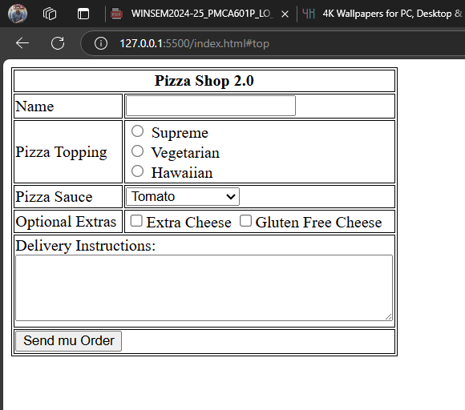

**B. Design a student registration form which takes student name, register number, DOB, program, email id, temporary address, permanent address, phone number.**

**CODE:**

<!DOCTYPE html>

<html lang="en">

<head>

<meta charset="UTF-8">

<meta name="viewport" content="width=device-width, initial-scale=1.0">

<title>Student Registration Form</title>

<style>

body {

font-family: Arial, sans-serif;

margin: 0;

padding: 0;

background-color: #dbdbf7;

}

.container {

max-width: 600px;

margin: 50px auto;

background-color: #ffffff;

padding: 20px;

border-radius: 8px;

box-shadow: 0 4px 8px rgba(0, 0, 0, 0.1);

}

h2 {

text-align: center;

color: #333;

}

label {

font-weight: bold;

margin-top: 10px;

display: block;

}

input, select, textarea {

width: 95%;

padding: 10px;

margin-top: 5px;

margin-bottom: 15px;

border: 1px solid #ccc;

border-radius: 4px;

}

input[type="submit"] {

background-color: #4CAF50;

color: white;

border: none;

cursor: pointer;

}

input[type="submit"]:hover {

background-color: #45a049;

}

</style>

</head>

<body>

<div class="container">

<h2>Student Registration Form</h2>

<form action="submit_registration.php" method="POST">

<label for="name">Student Name</label>

<input type="text" id="name" name="name" required>

<label for="reg_no">Register Number</label>

<input type="text" id="reg_no" name="reg_no" required>

<label for="dob">Date of Birth</label>

<input type="date" id="dob" name="dob" required>

<label for="program">Program</label>

<select id="program" name="program" required>

<option value="Bachelors">Bachelors</option>

<option value="Masters">Masters</option>

<option value="PhD">PhD</option>

</select>

<label for="email">Email ID</label>

<input type="email" id="email" name="email" required>

<label for="temp_address">Temporary Address</label>

<textarea id="temp_address" name="temp_address" rows="3" required></textarea>

<label for="perm_address">Permanent Address</label>

<textarea id="perm_address" name="perm_address" rows="3" required></textarea>

<label for="phone">Phone Number</label>

<input type="tel" id="phone" name="phone" pattern="[0-9]{10}" required>

<input type="submit" value="Register">

</form>

</div>

</body>

</html>

**OUTPUT:**

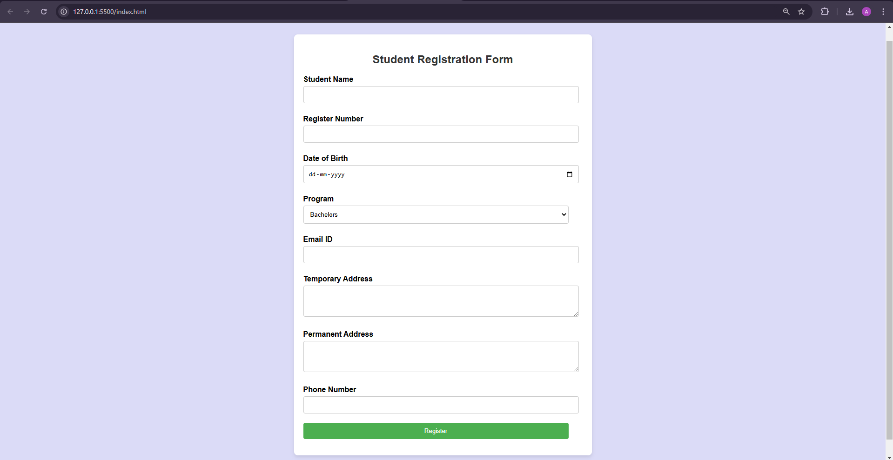

**1. Design a birthday greeting card for your friend using background cover image.**

**CODE:**

<!DOCTYPE html>

<html lang="en">

<head>

<meta charset="UTF-8">

<meta name="viewport" content="width=device-width, initial-scale=1.0">

<title>Birthday Greeting Card</title>

<style>

body {

margin: 0;

padding: 0;

display: flex;

justify-content: center;

align-items: center;

height: 100vh;

background: url('images/birthday-bg.jpg') no-repeat center center/cover;

font-family: Arial, sans-serif;

color: white;

text-align: center;

}

.card {

background-color: rgba(0, 0, 0, 0.6);

padding: 20px 40px;

border-radius: 15px;

box-shadow: 0 4px 15px rgba(0, 0, 0, 0.3);

}

h1 {

font-size: 2.5em;

margin-bottom: 10px;

color: #ffcc00;

}

p {

font-size: 1.2em;

margin-bottom: 15px;

}

.signature {

font-style: italic;

font-size: 1em;

margin-top: 20px;

color: #ffcc00;

}

</style>

</head>

<body>

<div class="card">

<h1>Happy Birthday, My Friend!</h1>

<p>Wishing you a day filled with laughter, love, and all the things that make you happiest.</p>

<p class="signature">- Your buddy</p>

</div>

</body>

</html>

**OUTPUT:**

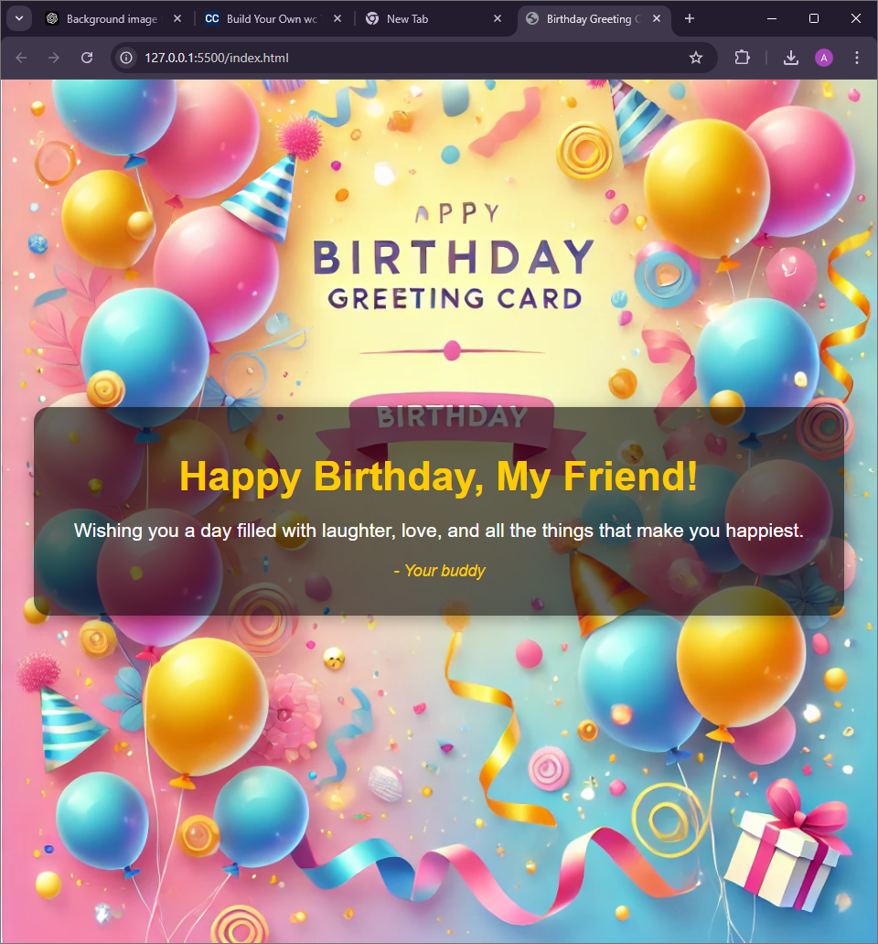

**2. Write CSS code to implement the following:**

**(a) Colorize text of a paragraph where RGB value is (51, 204, 0).**

**CODE:**

**OUTPUT:**

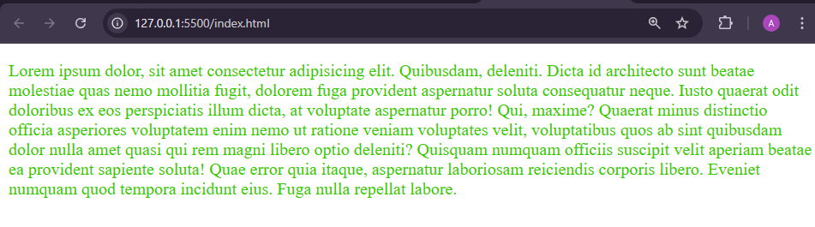

**(b) Place a background image rose.jpeg behind a single word “TEXT” written with a font size of 39 pixels.**

**CODE:**

<!DOCTYPE html>

<html lang="en">

<head>

<meta charset="UTF-8">

<meta name="viewport" content="width=device-width, initial-scale=1.0">

<title>Background Image Text</title>

<style>

body {

margin: 0;

padding: 0;

display: flex;

justify-content: center;

align-items: center;

height: 100vh;

background-color: #f0f0f0;

}

.text-container {

font-size: 39px;

font-family: Arial, sans-serif;

font-weight: bold;

color: white;

background: url('images/rose.jpeg') no-repeat center center;

background-size: cover;

width: 400px;

height: 200px;

display: flex;

justify-content: center;

align-items: center;

}

</style>

</head>

<body>

<div class="text-container">

TEXT

</div>

</body>

</html>

**OUTPUT:**



**(c) Place an image in the background of a page such that the image tiles only in the horizontal direction and the starting position is the horizontal and vertical center of the page.**

**CODE:**

<!DOCTYPE html>

<html lang="en">

<head>

<meta charset="UTF-8">

<meta name="viewport" content="width=device-width, initial-scale=1.0">

<title>Horizontal Tiling Background</title>

<style>

body {

margin: 0;

padding: 0;

height: 100vh;

background: url('images/rose.jpeg') repeat-x center center;

background-size: auto;

}

</style>

</head>

<body>

</body>

</html>

**OUTPUT:**

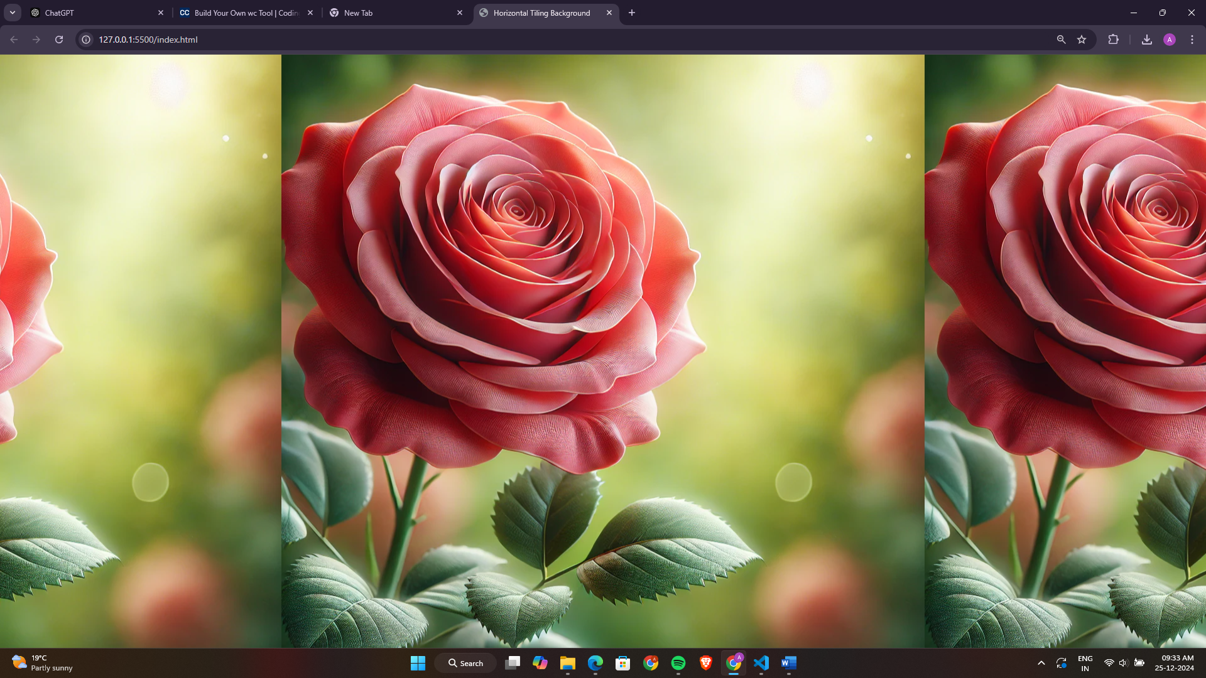

**3. Use CSS to write the text string “Cascading Style Sheet” dark red in color and in small caps an in a size that approximately covers 50% of the page width. The text should be a hyperlink pointing to a file Test.HTM, but without any underline. The stylesheet should remain in an external file.**

**CODE:**

**Index.html:**

<!DOCTYPE html>

<html lang="en">

<head>

<meta charset="UTF-8">

<meta name="viewport" content="width=device-width, initial-scale=1.0">

<title>Text Styling</title>

<link rel="stylesheet" href="style.css">

</head>

<body>

<a href="Test.HTM">Cascading Style Sheet</a>

</body>

</html>

**Style.css:**

a {

color: darkred;

font-variant: small-caps;

font-size: 5vw;

text-decoration: none;

display: inline-block;

width: 50%;

text-align: center;

}

**OUTPUT:**

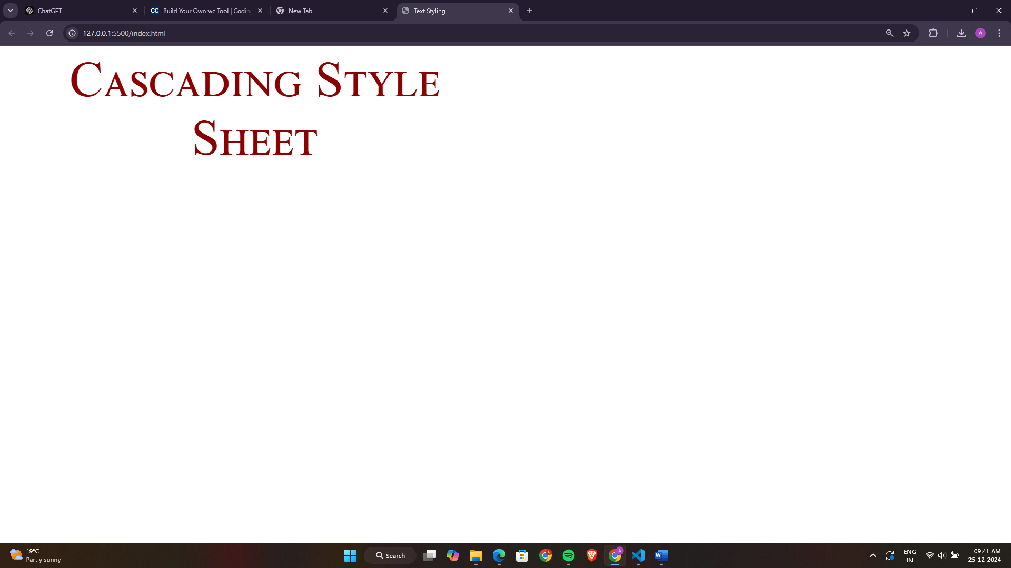

**4. Use CSS code to create the following page: The page contains the following text – “Now paragraphs can have a border of their own”. The text should be positioned 100 pixels from the top and 40% from the right margin of the browser. The font is “Times New Roman” in italics, the letter size 30 pixels and lime color text. The text is enclosed on all sides by a grooved border with the colors CC99CC, 99CCCC, CCCC99, C9C9C9 starting from the right border anti-clockwise respectively. The corresponding border thickness is 5 pt, 10 px, 2 cm, 1 cm.. The letter spacing should be 2 pixels and there should be a horizontal line through it.**

**CODE:**

<!DOCTYPE html>

<html lang="en">

<head>

<meta charset="UTF-8">

<meta name="viewport" content="width=device-width, initial-scale=1.0">

<title>Document</title>

<style>

body{

background-color: coral;

}

p{

margin-top: 100px;

margin-right: 40%;

font-family: 'Times New Roman', Times, serif;

font-style: italic;

font-size: 30px;

color: lime;

border-right: 5pt #CC99CC groove;

border-top: 10px #99CCCC groove;

border-left: 2cm #CCCC99 groove;

border-bottom: 1cm #C9C9C9 groove;

letter-spacing: 2px;

text-decoration: line-through;

}

</style>

</head>

<body>

<p>"Now paragraphs can have a border of their own"</p>

</body>

</html>

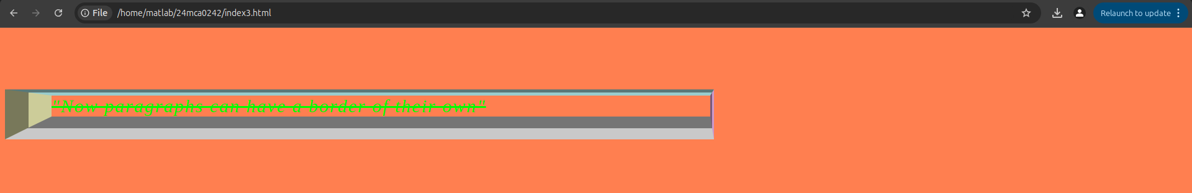**OUTPUT:**

**5. Write CSS code to implement the following:**

**A border around an image element such that the top and bottom borders are 3 pixels wide and of type “dashed” while the left and right borders are 5 pixels wide and of type “solid”. All borders are green in color.**

**CODE:**

<!DOCTYPE html>

<html lang="en">

<head>

<meta charset="UTF-8">

<meta name="viewport" content="width=device-width, initial-scale=1.0">

<title>Image Border</title>

<style>

img {

border-top: 3px dashed green;

border-bottom: 3px dashed green;

border-left: 5px solid green;

border-right: 5px solid green;

}

</style>

</head>

<body>

<img src="images/img1.jpg" alt="Sample Image" width="800px">

</body>

</html>

**OUTPUT:**

